Topic: Area Surface and Volume

Shajia Tabassum Orthe (230101)

Srabony Akter (230134)

**Area and Volume of a surface**

Ex-01. Find the length of the arc of the parabola extending from the vertex to one extremity of a latus rectum.

Solution:  
Here, 



∴ = √

Put, 

Arc length = 

= 

= 

= 

= 

= 

= 

= 

(Ans.)

Ex-02: Find the complete perimeter of the curve given  ,.

Solution:

Given that,

 (i)

and(ii)

Squaring and adding (i) and (ii) we get,

 

= 

= 1

Here, 1

Or, 

Or, 



Length = 

= 

=

= 

= 2

(Ans)

Ex -03:Prove that the length of the loop of the .

Solution:

Here, 







∴whole length = 

= 

= 

= 

= 



(Ans)

Ex-04: Show that te length of the curve the parabola cut by the line 3y = 8x is .

Solution:

Here, 







Again,



Length 









= 





(Ans.)

Ex – 06: Find the area of the surface inside the surface .

Solution :

Area = 

Clearly, 







Put,



Also, 





















(Ans.)

Ex-07: Show that the area of the surface of the paraboloid which lies between thr planes z=0and z = a is .

Solution:

Here, 









Projection of the surface on the plane z = 0 is or is a circle between and 















(Proved)

Ex-08: Find the volume of the wedge intercepted between the cylinder and planes .

Solution:

Limits of z are x to 2x

Limits of y are to 

Limits of x are 0 to 2a

 Volume = 

 where 























(Ans.)

Ex-13: Find the volume of the ellipse .

Solution:

Let us find out the volume in the first positive quadrant











Similarly,











Total Volume 

(Ans.)

Ex-14: Find the volume bounded by .

Solution :

Given, 

Limits of z are from 0 to 

Limits of y are from 0 to 

Limits of x are from 0 to 1

In , put y = 0

= 0



We want volume in the first octant so we take limits of x from 0 to 1.







Put,

 ,

when, x= 1 then 

x = 0 then 



(Ans.)

Ex-15: Find the volume bounded by the planes  and .

Solution :

Given  and 

Limits of z are 0 to 

Limits of y are 0 to 2-x

Limits of z are 0 to 2



















(Ans.)

Ex-16: Evaluate taken over the trianglularegion T bounded by the lines 

Solution :

Here the limits of y are 0 to x

The limits of x are 0 to 1











(Ans.)

Ex-18: Find the volume of the spherical surface going within the cone .

Solution :

Given,  

And  

Eliminating a nd y from (1) and (2) we get,









From 2 we get, 

Now limits of y are  to 

And limits of x are to 















(Ans.)

**1.** Find the area of the region bounded above by {"mathml":"<math style=\"font-family:stix;font-size:16px;\" xmlns=\"http://www.w3.org/1998/Math/MathML\"><mi>y</mi><mo>=</mo><mi>x</mi><mo>+</mo><mn>6</mn></math>","origin":"MathType Legacy","version":"v3.18.2"};bounded below by {"mathml":"<math xmlns=\"http://www.w3.org/1998/Math/MathML\" style=\"font-family:stix;font-size:16px;\"><mi>y</mi><mo>=</mo><msup><mi>x</mi><mn>2</mn></msup></math>","origin":"MathType Legacy","version":"v3.18.2"} and bounded on the sides by the lines {"mathml":"<math xmlns=\"http://www.w3.org/1998/Math/MathML\" style=\"font-family:stix;font-size:16px;\"><mi>x</mi><mo>=</mo><mn>0</mn></math>","origin":"MathType Legacy","version":"v3.18.2"} and {"mathml":"<math xmlns=\"http://www.w3.org/1998/Math/MathML\" style=\"font-family:stix;font-size:16px;\"><mi>x</mi><mo>=</mo><mn>2</mn></math>","origin":"MathType Legacy","version":"v3.18.2"}.

**Solve:**  
The region and a cross section are shown in Fig. 1. The cross section extends from  
{"mathml":"<math xmlns=\"http://www.w3.org/1998/Math/MathML\" style=\"font-family:stix;font-size:16px;\"><mi>g</mi><mfenced><mi>x</mi></mfenced><mo>=</mo><msup><mi>x</mi><mn>2</mn></msup></math>","origin":"MathType Legacy","version":"v3.18.2"} on the bottom to {"mathml":"<math xmlns=\"http://www.w3.org/1998/Math/MathML\" style=\"font-family:stix;font-size:16px;\"><mi>f</mi><mfenced><mi>x</mi></mfenced><mo>=</mo><mi>x</mi><mo>+</mo><mn>6</mn></math>","origin":"MathType Legacy","version":"v3.18.2"} on the top. If the cross section is moved through the region, then its leftmost position will be {"mathml":"<math xmlns=\"http://www.w3.org/1998/Math/MathML\" style=\"font-family:stix;font-size:16px;\"><mi>x</mi><mo>=</mo><mn>0</mn></math>","origin":"MathType Legacy","version":"v3.18.2"} and its rightmost position will be {"mathml":"<math xmlns=\"http://www.w3.org/1998/Math/MathML\" style=\"font-family:stix;font-size:16px;\"><mi>x</mi><mo>=</mo><mn>2</mn></math>","origin":"MathType Legacy","version":"v3.18.2"} thus

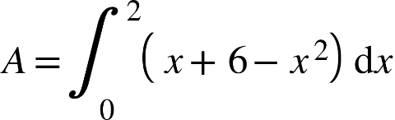

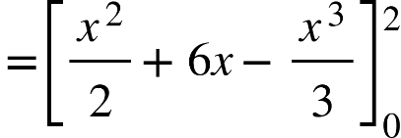

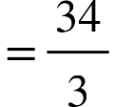

**2**. Find the area of the region that is enclosed between the curves {"mathml":"<math xmlns=\"http://www.w3.org/1998/Math/MathML\" style=\"font-family:stix;font-size:16px;\"><mi>y</mi><mo>=</mo><msup><mi>x</mi><mn>2</mn></msup></math>","origin":"MathType Legacy","version":"v3.18.2"} and {"mathml":"<math xmlns=\"http://www.w3.org/1998/Math/MathML\" style=\"font-family:stix;font-size:16px;\"><mi>y</mi><mo>=</mo><mi>x</mi><mo>+</mo><mn>6</mn></math>","origin":"MathType Legacy","version":"v3.18.2"}

**Solve:**

The lower boundary is {"mathml":"<math xmlns=\"http://www.w3.org/1998/Math/MathML\" style=\"font-family:stix;font-size:16px;\"><mi>y</mi><mo>&#xA0;</mo><mo>=</mo><mo>&#xA0;</mo><msup><mi>x</mi><mn>2</mn></msup></math>","origin":"MathType Legacy","version":"v3.18.2"} and the upper boundary is {"mathml":"<math xmlns=\"http://www.w3.org/1998/Math/MathML\" style=\"font-family:stix;font-size:16px;\"><mi>y</mi><mo>&#xA0;</mo><mo>=</mo><mo>&#xA0;</mo><mi>x</mi><mo>&#xA0;</mo><mo>+</mo><mo>&#xA0;</mo><mn>6</mn><mo>.</mo></math>","origin":"MathType Legacy","version":"v3.18.2"}

The endpoints are obtained by setting:

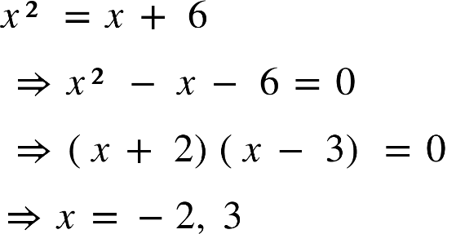

Thus the area is 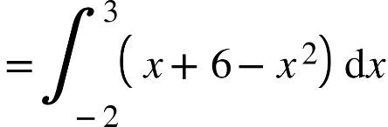

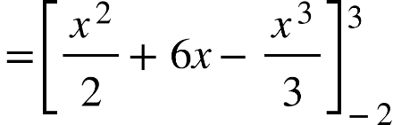

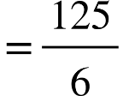

Arc length:

Let {"mathml":"<math style=\"font-family:stix;font-size:16px;\" xmlns=\"http://www.w3.org/1998/Math/MathML\"><mi>y</mi><mo>=</mo><mi>f</mi><mfenced><mi>x</mi></mfenced></math>","origin":"MathType Legacy","version":"v3.18.2"} be a curve in the interval 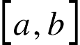 Divide the interval b into n parts by inserting points {"mathml":"<math style=\"font-family:stix;font-size:16px;\" xmlns=\"http://www.w3.org/1998/Math/MathML\"><msub><mi>x</mi><mn>1</mn></msub></math>","origin":"MathType Legacy","version":"v3.18.2"} ,{"mathml":"<math xmlns=\"http://www.w3.org/1998/Math/MathML\" style=\"font-family:stix;font-size:16px;\"><msub><mi>x</mi><mn>2</mn></msub></math>","origin":"MathType Legacy","version":"v3.18.2"} ,……,{"mathml":"<math xmlns=\"http://www.w3.org/1998/Math/MathML\" style=\"font-family:stix;font-size:16px;\"><msub><mi>x</mi><mrow><mi>n</mi><mo>-</mo><mn>1</mn></mrow></msub></math>","origin":"MathType Legacy","version":"v3.18.2"} between {"mathml":"<math xmlns=\"http://www.w3.org/1998/Math/MathML\" style=\"font-family:stix;font-size:16px;\"><msub><mi>x</mi><mn>0</mn></msub><mo>=</mo><mi>a</mi></math>","origin":"MathType Legacy","version":"v3.18.2"} and {"mathml":"<math xmlns=\"http://www.w3.org/1998/Math/MathML\" style=\"font-family:stix;font-size:16px;\"><msub><mi>x</mi><mrow><mi>n</mi><mo>&#xA0;</mo></mrow></msub><mo>=</mo><mi>b</mi></math>","origin":"MathType Legacy","version":"v3.18.2"} takes {"mathml":"<math xmlns=\"http://www.w3.org/1998/Math/MathML\" style=\"font-family:stix;font-size:16px;\"><msub><mi>p</mi><mn>0</mn></msub></math>","origin":"MathType Legacy","version":"v3.18.2"} ,{"mathml":"<math xmlns=\"http://www.w3.org/1998/Math/MathML\" style=\"font-family:stix;font-size:16px;\"><msub><mi>p</mi><mn>1</mn></msub></math>","origin":"MathType Legacy","version":"v3.18.2"} ,…..{"mathml":"<math xmlns=\"http://www.w3.org/1998/Math/MathML\" style=\"font-family:stix;font-size:16px;\"><msub><mi>p</mi><mi>n</mi></msub></math>","origin":"MathType Legacy","version":"v3.18.2"} with abscissa {"mathml":"<math xmlns=\"http://www.w3.org/1998/Math/MathML\" style=\"font-family:stix;font-size:16px;\"><msub><mi>x</mi><mn>0</mn></msub></math>","origin":"MathType Legacy","version":"v3.18.2"} ,{"mathml":"<math xmlns=\"http://www.w3.org/1998/Math/MathML\" style=\"font-family:stix;font-size:16px;\"><msub><mi>x</mi><mn>1</mn></msub></math>","origin":"MathType Legacy","version":"v3.18.2"} . {"mathml":"<math xmlns=\"http://www.w3.org/1998/Math/MathML\" style=\"font-family:stix;font-size:16px;\"><msub><mi>p</mi><mn>0</mn></msub><mo>&#xA0;</mo><msub><mi>p</mi><mn>1</mn></msub></math>","origin":"MathType Legacy","version":"v3.18.2"} ,{"mathml":"<math xmlns=\"http://www.w3.org/1998/Math/MathML\" style=\"font-family:stix;font-size:16px;\"><msub><mi>p</mi><mrow><mn>1</mn><mo>&#xA0;</mo></mrow></msub><mo>&#xA0;</mo><msub><mi>p</mi><mn>2</mn></msub></math>","origin":"MathType Legacy","version":"v3.18.2"} ,…….{"mathml":"<math style=\"font-family:stix;font-size:16px;\" xmlns=\"http://www.w3.org/1998/Math/MathML\"><msub><mi>p</mi><mrow><mi>n</mi><mo>-</mo><mn>1</mn><mo>&#xA0;</mo></mrow></msub><mo>&#xA0;</mo><msub><mi>p</mi><mi>n</mi></msub></math>","origin":"MathType Legacy","version":"v3.18.2"} are it lines.let of the line segment

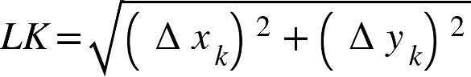



Now,

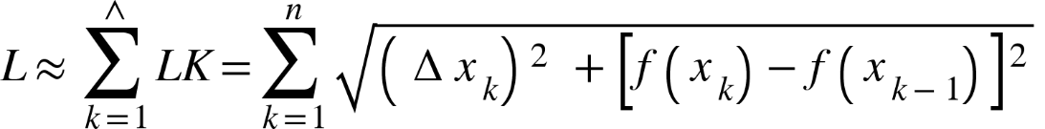

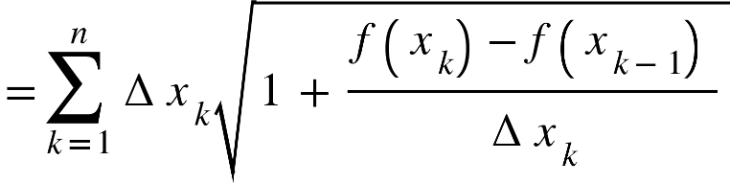

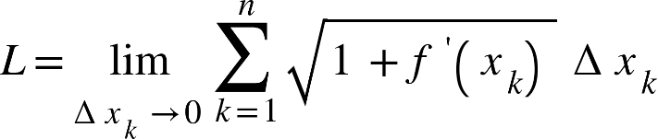

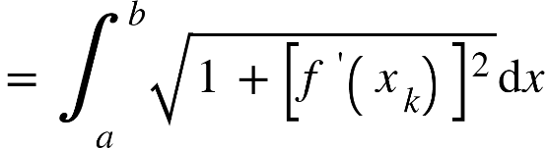

1.Find the arc length of the curve {"mathml":"<mml:math style=\"font-family:stix;font-size:16px;\" xmlns:m=\"http://schemas.openxmlformats.org/officeDocument/2006/math\" xmlns:mml=\"http://www.w3.org/1998/Math/MathML\"><mml:mstyle mathsize=\"16px\"><mml:mi>y</mml:mi><mml:mo>=</mml:mo><mml:msup><mml:mi>x</mml:mi><mml:mrow><mml:mn>3</mml:mn><mml:mo>/</mml:mo><mml:mn>2</mml:mn></mml:mrow></mml:msup></mml:mstyle></mml:math>","origin":"MathType Legacy","version":"v3.18.2"} from {"mathml":"<mml:math style=\"font-family:stix;font-size:16px;\" xmlns:m=\"http://schemas.openxmlformats.org/officeDocument/2006/math\" xmlns:mml=\"http://www.w3.org/1998/Math/MathML\"><mml:mstyle mathsize=\"16px\"><mml:mo>(</mml:mo><mml:mn>1,1</mml:mn><mml:mo>)</mml:mo></mml:mstyle></mml:math>","origin":"MathType Legacy","version":"v3.18.2"} to   
solve: 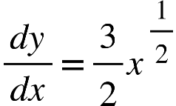 since the curve entended from to

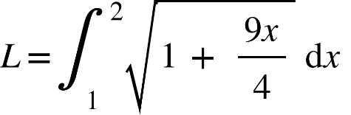 here,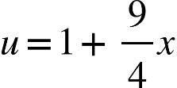

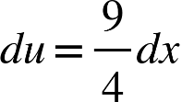

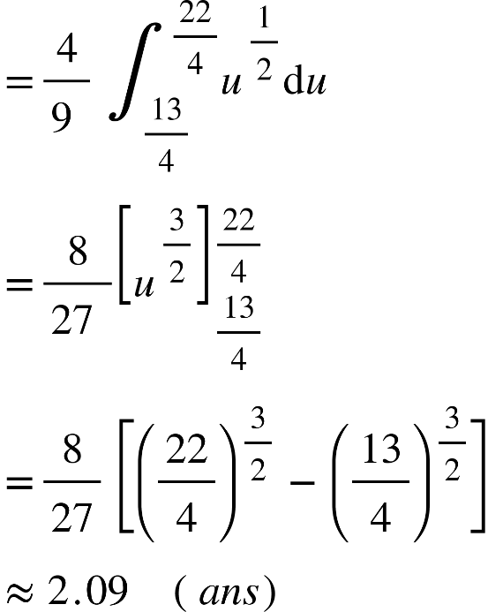

2.Find the area of the quadrant of the ellipse 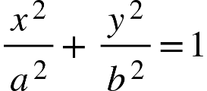 between the major and minor axes.

Solve:- The area is bounded by the curve, the -axis and the ordinates {"mathml":"<mml:math style=\"font-family:stix;font-size:16px;\" xmlns:m=\"http://schemas.openxmlformats.org/officeDocument/2006/math\" xmlns:mml=\"http://www.w3.org/1998/Math/MathML\"><mml:mstyle mathsize=\"16px\"><mml:mi>x</mml:mi><mml:mo>=</mml:mo><mml:mn>0</mml:mn></mml:mstyle></mml:math>","origin":"MathType Legacy","version":"v3.18.2"} and {"mathml":"<mml:math style=\"font-family:stix;font-size:16px;\" xmlns:m=\"http://schemas.openxmlformats.org/officeDocument/2006/math\" xmlns:mml=\"http://www.w3.org/1998/Math/MathML\"><mml:mstyle mathsize=\"16px\"><mml:mi>x</mml:mi><mml:mo>=</mml:mo><mml:mi>a</mml:mi></mml:mstyle></mml:math>","origin":"MathType Legacy","version":"v3.18.2"}.  
The required area 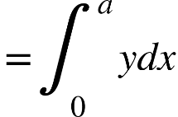 B P

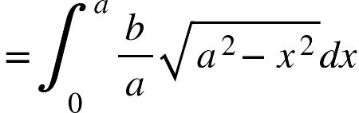 o A

{"mathml":"<math style=\"font-family:stix;font-size:16px;\" xmlns=\"http://www.w3.org/1998/Math/MathML\"><mo>&#xA0;</mo><mo>&#xA0;</mo><mo>&#xA0;</mo><mo>&#xA0;</mo><mo>&#xA0;</mo><mo>&#xA0;</mo><mo>&#xA0;</mo><mo>&#xA0;</mo><mo>&#xA0;</mo><mo>&#xA0;</mo><mo>&#xA0;</mo><mo>&#xA0;</mo><mo>&#xA0;</mo><mo>&#xA0;</mo><mo>&#xA0;</mo><mo>&#xA0;</mo><mo>&#xA0;</mo><mo>&#xA0;</mo><mo>&#xA0;</mo><mo>=</mo><mfrac><mi>b</mi><mi>a</mi></mfrac><msubsup><mo>&#x222B;</mo><mn>0</mn><mfrac><mi mathvariant=\"normal\">&#x3C0;</mi><mn>2</mn></mfrac></msubsup><mi>a</mi><mi>cos</mi><mi>&#x3B8;</mi><mo>&#xA0;</mo><mi>a</mi><mi>cos</mi><mi>&#x3B8;</mi><mo>d</mo><mi>&#x3B8;</mi><mo>&#xA0;</mo><mo>&#xA0;</mo><mo>&#xA0;</mo><mo>&#xA0;</mo><mo>&#xA0;</mo><mo>&#xA0;</mo><mo>&#xA0;</mo><mo>&#xA0;</mo><mo>&#xA0;</mo><mo>&#xA0;</mo><mo>&#xA0;</mo><mo>&#xA0;</mo><mo>&#xA0;</mo><mo>&#xA0;</mo><mo>&#xA0;</mo><mo>&#xA0;</mo><mo>&#xA0;</mo><mo>&#xA0;</mo><mo>&#xA0;</mo><mo>&#xA0;</mo><mo>&#xA0;</mo><mo>&#xA0;</mo><mo>&#xA0;</mo><mo>&#xA0;</mo><mo>&#xA0;</mo><mo>&#xA0;</mo><mo>&#xA0;</mo><mo>&#xA0;</mo><mi>h</mi><mi>e</mi><mi>r</mi><mi>e</mi><mo>,</mo><mi>x</mi><mo>=</mo><mi>a</mi><mi>sin</mi><mi>&#x3B8;</mi><mspace linebreak=\"newline\"/><mo>&#xA0;</mo><mo>&#xA0;</mo><mo>&#xA0;</mo><mo>&#xA0;</mo><mo>&#xA0;</mo><mo>&#xA0;</mo><mo>&#xA0;</mo><mo>&#xA0;</mo><mo>&#xA0;</mo><mo>&#xA0;</mo><mo>&#xA0;</mo><mo>&#xA0;</mo><mo>&#xA0;</mo><mo>&#xA0;</mo><mo>&#xA0;</mo><mo>&#xA0;</mo><mo>&#xA0;</mo><mo>&#xA0;</mo><mo>&#xA0;</mo><mo>=</mo><mi>a</mi><mi>b</mi><msubsup><mo>&#x222B;</mo><mn>0</mn><mfrac><mi mathvariant=\"normal\">&#x3C0;</mi><mn>2</mn></mfrac></msubsup><msup><mi>cos</mi><mn>2</mn></msup><mi>&#x3B8;</mi><mo>d</mo><mi>&#x3B8;</mi><mspace linebreak=\"newline\"/><mo>&#xA0;</mo><mo>&#xA0;</mo><mo>&#xA0;</mo><mo>&#xA0;</mo><mo>&#xA0;</mo><mo>&#xA0;</mo><mo>&#xA0;</mo><mo>&#xA0;</mo><mo>&#xA0;</mo><mo>&#xA0;</mo><mo>&#xA0;</mo><mo>&#xA0;</mo><mo>&#xA0;</mo><mo>&#xA0;</mo><mo>&#xA0;</mo><mo>&#xA0;</mo><mo>&#xA0;</mo><mo>&#xA0;</mo><mo>&#xA0;</mo><mo>=</mo><mfrac><mrow><mi>a</mi><mi>b</mi></mrow><mrow><mn>2</mn><mo>&#xA0;</mo></mrow></mfrac><mo>&#xA0;</mo><msubsup><mo>&#x222B;</mo><mn>0</mn><mfrac><mi mathvariant=\"normal\">&#x3C0;</mi><mn>2</mn></mfrac></msubsup><mfenced><mrow><mn>1</mn><mo>-</mo><mi>cos</mi><mn>2</mn><mi>&#x3B8;</mi></mrow></mfenced><mo>d</mo><mi>&#x3B8;</mi><mspace linebreak=\"newline\"/><mo>&#xA0;</mo><mo>&#xA0;</mo><mo>&#xA0;</mo><mo>&#xA0;</mo><mo>&#xA0;</mo><mo>&#xA0;</mo><mo>&#xA0;</mo><mo>&#xA0;</mo><mo>&#xA0;</mo><mo>&#xA0;</mo><mo>&#xA0;</mo><mo>&#xA0;</mo><mo>&#xA0;</mo><mo>&#xA0;</mo><mo>&#xA0;</mo><mo>&#xA0;</mo><mo>&#xA0;</mo><mo>&#xA0;</mo><mo>&#xA0;</mo><mo>=</mo><mfrac><mrow><mi>a</mi><mi>b</mi></mrow><mn>2</mn></mfrac><mo>&#xA0;</mo><mfenced><mrow><mfrac><mi mathvariant=\"normal\">&#x3C0;</mi><mrow><mn>2</mn><mo>&#xA0;</mo></mrow></mfrac><mo>&#xA0;</mo><mo>-</mo><mn>0</mn></mrow></mfenced><mspace linebreak=\"newline\"/><mo>&#xA0;</mo><mo>&#xA0;</mo><mo>&#xA0;</mo><mo>&#xA0;</mo><mo>&#xA0;</mo><mo>&#xA0;</mo><mo>&#xA0;</mo><mo>&#xA0;</mo><mo>&#xA0;</mo><mo>&#xA0;</mo><mo>&#xA0;</mo><mo>&#xA0;</mo><mo>&#xA0;</mo><mo>&#xA0;</mo><mo>&#xA0;</mo><mo>&#xA0;</mo><mo>&#xA0;</mo><mo>&#xA0;</mo><mo>&#xA0;</mo><mo>&#xA0;</mo><mo>=</mo><mfrac><mn>1</mn><mn>4</mn></mfrac><mi>&#x3C0;ab</mi><mo>&#xA0;</mo><mo>&#xA0;</mo><mo>&#xA0;</mo><mo>&#xA0;</mo><mo>&#xA0;</mo><mo>&#xA0;</mo><mo>&#xA0;</mo><mo>&#xA0;</mo><mo>&#xA0;</mo><mo>&#xA0;</mo><mo>&#xA0;</mo><mo>&#xA0;</mo><mo>&#xA0;</mo><mo>&#xA0;</mo><mspace linebreak=\"newline\"/><mo>&#xA0;</mo><mo>&#xA0;</mo><mo>&#xA0;</mo><mo>&#xA0;</mo><mo>&#xA0;</mo><mo>&#xA0;</mo><mo>&#xA0;</mo><mo>&#xA0;</mo><mo>&#xA0;</mo><mo>&#xA0;</mo><mo>&#xA0;</mo><mo>&#xA0;</mo><mo>&#xA0;</mo><mo>&#xA0;</mo><mo>&#xA0;</mo><mo>&#xA0;</mo><mo>&#xA0;</mo><mo>&#xA0;</mo><mo>&#xA0;</mo><mo>&#xA0;</mo><mo>&#xA0;</mo><mo>&#xA0;</mo><mo>&#xA0;</mo><mo>&#xA0;</mo><mo>&#xA0;</mo><mo>&#xA0;</mo><mo>&#xA0;</mo><mo>&#xA0;</mo><mo>&#xA0;</mo><mo>&#xA0;</mo><mo>&#xA0;</mo><mo>&#xA0;</mo><mo>&#xA0;</mo><mo>&#xA0;</mo><mo>&#xA0;</mo><mo>&#xA0;</mo><mo>&#xA0;</mo><mo>&#xA0;</mo><mo>&#xA0;</mo><mo>&#xA0;</mo><mo>&#xA0;</mo></math>","origin":"MathType Legacy","version":"v3.18.2"}

So,The area of the whole ellipse is 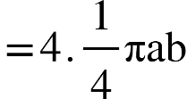

{"mathml":"<math xmlns=\"http://www.w3.org/1998/Math/MathML\" style=\"font-family:stix;font-size:16px;\"><mo>=</mo><mi>&#x3C0;ab</mi></math>","origin":"MathType Legacy","version":"v3.18.2"}

# Area of a circle with radius is obtain by setting {"mathml":"<mml:math style=\"font-family:stix;font-size:16px;\" xmlns:m=\"http://schemas.openxmlformats.org/officeDocument/2006/math\" xmlns:mml=\"http://www.w3.org/1998/Math/MathML\"><mml:mstyle mathsize=\"16px\"><mml:mi>a</mml:mi><mml:mo>=</mml:mo><mml:mi>b</mml:mi></mml:mstyle></mml:math>","origin":"MathType Legacy","version":"v3.18.2"} in the above result Area of circle {"mathml":"<mml:math style=\"font-family:stix;font-size:16px;\" xmlns:m=\"http://schemas.openxmlformats.org/officeDocument/2006/math\" xmlns:mml=\"http://www.w3.org/1998/Math/MathML\"><mml:mstyle mathsize=\"16px\"><mml:mo>=</mml:mo><mml:mi>&#x3C0;</mml:mi><mml:msup><mml:mi>a</mml:mi><mml:mn>2</mml:mn></mml:msup></mml:mstyle></mml:math>","origin":"MathType Legacy","version":"v3.18.2"}

3.Find the area of the loop of the curve

{"mathml":"<mml:math style=\"font-family:stix;font-size:16px;\" xmlns:m=\"http://schemas.openxmlformats.org/officeDocument/2006/math\" xmlns:mml=\"http://www.w3.org/1998/Math/MathML\"><mml:mstyle mathsize=\"16px\"><mml:mi>x</mml:mi><mml:msup><mml:mi>y</mml:mi><mml:mn>2</mml:mn></mml:msup><mml:mo>-</mml:mo><mml:mo>(</mml:mo><mml:mi>x</mml:mi><mml:mo>+</mml:mo><mml:mi>a</mml:mi><mml:msup><mml:mo>)</mml:mo><mml:mn>2</mml:mn></mml:msup><mml:mo>(</mml:mo><mml:mi>x</mml:mi><mml:mo>+</mml:mo><mml:mn>2</mml:mn><mml:mi>a</mml:mi><mml:mo>)</mml:mo><mml:mo>=</mml:mo><mml:mn>0</mml:mn></mml:mstyle></mml:math>","origin":"MathType Legacy","version":"v3.18.2"}

solve-

P

A B o

The equation can be put in the form {"mathml":"<mml:math style=\"font-family:stix;font-size:16px;\" xmlns:m=\"http://schemas.openxmlformats.org/officeDocument/2006/math\" xmlns:mml=\"http://www.w3.org/1998/Math/MathML\"><mml:mstyle mathsize=\"16px\"><mml:msup><mml:mi>y</mml:mi><mml:mn>2</mml:mn></mml:msup><mml:mo>=</mml:mo><mml:mo>-</mml:mo><mml:mfenced open=\"{\" close=\"}\" separators=\"|\"><mml:mrow><mml:mfenced separators=\"|\"><mml:mrow><mml:mi>x</mml:mi><mml:mo>+</mml:mo><mml:msup><mml:mi>a</mml:mi><mml:mn>2</mml:mn></mml:msup></mml:mrow></mml:mfenced><mml:mo>(</mml:mo><mml:mi>x</mml:mi><mml:mo>+</mml:mo><mml:mn>2</mml:mn><mml:mi>a</mml:mi><mml:mo>)</mml:mo></mml:mrow></mml:mfenced><mml:mo>/</mml:mo><mml:mi>x</mml:mi></mml:mstyle></mml:math>","origin":"MathType Legacy","version":"v3.18.2"}.  
{"mathml":"<mml:math style=\"font-family:stix;font-size:16px;\" xmlns:m=\"http://schemas.openxmlformats.org/officeDocument/2006/math\" xmlns:mml=\"http://www.w3.org/1998/Math/MathML\"><mml:mstyle mathsize=\"16px\"><mml:mi>y</mml:mi><mml:mo>=</mml:mo><mml:mn>0</mml:mn></mml:mstyle></mml:math>","origin":"MathType Legacy","version":"v3.18.2"} at and at where {"mathml":"<math style=\"font-family:stix;font-size:16px;\" xmlns=\"http://www.w3.org/1998/Math/MathML\"><mi>x</mi><mo>=</mo><mi>a</mi><mo>&#xA0;</mo></math>","origin":"MathType Legacy","version":"v3.18.2"}and {"mathml":"<math xmlns=\"http://www.w3.org/1998/Math/MathML\" style=\"font-family:stix;font-size:16px;\"><mi>x</mi><mo>=</mo><mn>2</mn><mi>a</mi></math>","origin":"MathType Legacy","version":"v3.18.2"} and {"mathml":"<mml:math style=\"font-family:stix;font-size:16px;\" xmlns:m=\"http://schemas.openxmlformats.org/officeDocument/2006/math\" xmlns:mml=\"http://www.w3.org/1998/Math/MathML\"><mml:mstyle mathsize=\"16px\"><mml:mi>y</mml:mi><mml:mo>&#x2192;</mml:mo><mml:mo>&#xB1;</mml:mo><mml:mi mathvariant=\"normal\">&#x221E;</mml:mi></mml:mstyle></mml:math>","origin":"MathType Legacy","version":"v3.18.2"} as . For the +ve values of , as well as for values of s imaginary. Thus, loop lie between {"mathml":"<mml:math style=\"font-family:stix;font-size:16px;\" xmlns:m=\"http://schemas.openxmlformats.org/officeDocument/2006/math\" xmlns:mml=\"http://www.w3.org/1998/Math/MathML\"><mml:mstyle mathsize=\"16px\"><mml:mi>x</mml:mi><mml:mo>=</mml:mo><mml:mo>-</mml:mo><mml:mn>2</mml:mn><mml:mi>a</mml:mi></mml:mstyle></mml:math>","origin":"MathType Legacy","version":"v3.18.2"} to {"mathml":"<mml:math style=\"font-family:stix;font-size:16px;\" xmlns:m=\"http://schemas.openxmlformats.org/officeDocument/2006/math\" xmlns:mml=\"http://www.w3.org/1998/Math/MathML\"><mml:mstyle mathsize=\"16px\"><mml:mi>x</mml:mi><mml:mo>=</mml:mo><mml:mo>-</mml:mo><mml:mi>a</mml:mi></mml:mstyle></mml:math>","origin":"MathType Legacy","version":"v3.18.2"}.  
Thus the required area of the loop{"mathml":"<math style=\"font-family:stix;font-size:16px;\" xmlns=\"http://www.w3.org/1998/Math/MathML\"><mo>=</mo><mn>2</mn><mo>;</mo><mi>a</mi><mi>r</mi><mi>e</mi><mi>a</mi><mo>&#xA0;</mo><mi>A</mi><mi>P</mi><mi>B</mi></math>","origin":"MathType Legacy","version":"v3.18.2"}

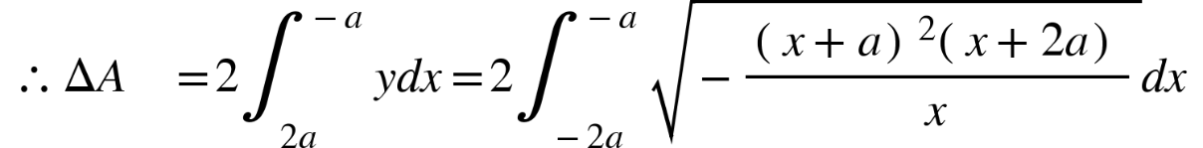

Let, {"mathml":"<math style=\"font-family:stix;font-size:16px;\" xmlns=\"http://www.w3.org/1998/Math/MathML\"><mi>z</mi><mo>=</mo><mi>x</mi><mo>+</mo><mi>a</mi></math>","origin":"MathType Legacy","version":"v3.18.2"}

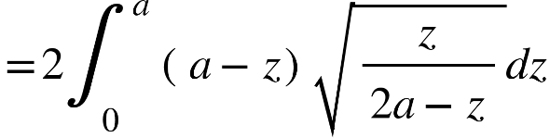

Also,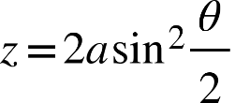

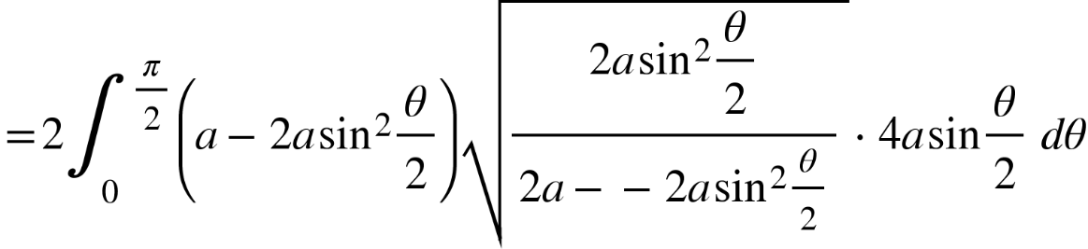

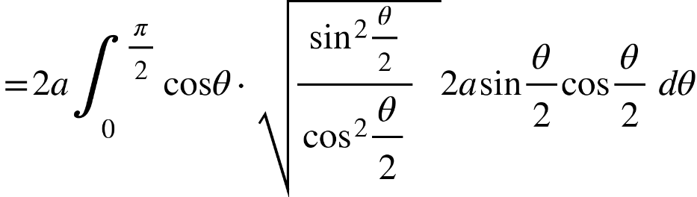

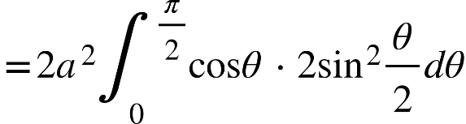

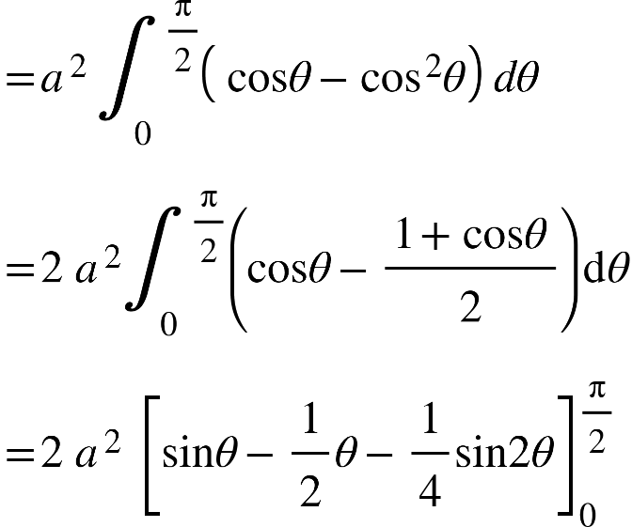

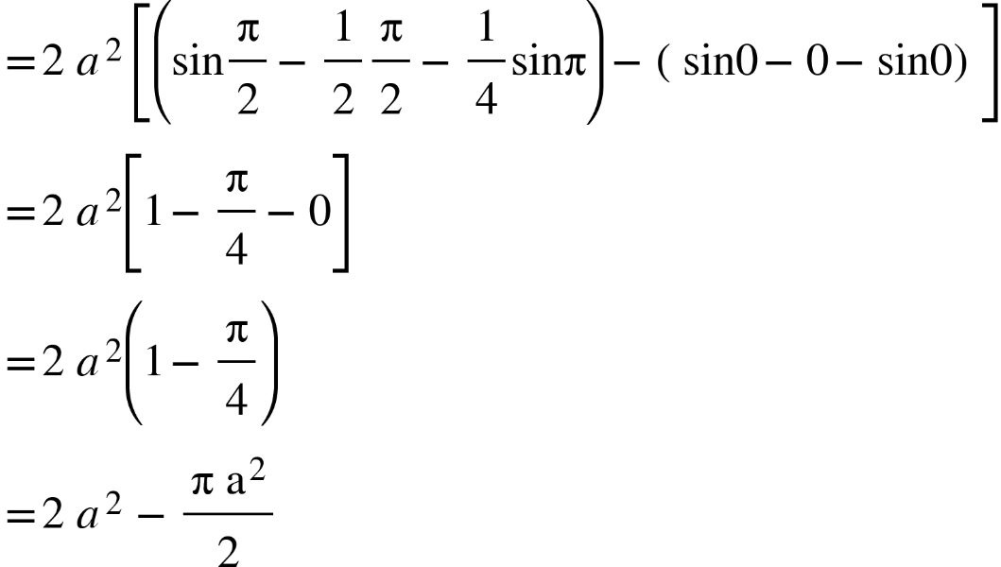

4. Find the area above the, -axis. inelicded between the parabola {"mathml":"<mml:math style=\"font-family:stix;font-size:16px;\" xmlns:m=\"http://schemas.openxmlformats.org/officeDocument/2006/math\" xmlns:mml=\"http://www.w3.org/1998/Math/MathML\"><mml:mstyle mathsize=\"16px\"><mml:msup><mml:mi>y</mml:mi><mml:mn>2</mml:mn></mml:msup><mml:mo>=</mml:mo><mml:mi>a</mml:mi><mml:mi>x</mml:mi></mml:mstyle></mml:math>","origin":"MathType Legacy","version":"v3.18.2"} and the circle {"mathml":"<mml:math style=\"font-family:stix;font-size:16px;\" xmlns:m=\"http://schemas.openxmlformats.org/officeDocument/2006/math\" xmlns:mml=\"http://www.w3.org/1998/Math/MathML\"><mml:mstyle mathsize=\"16px\"><mml:msup><mml:mi>x</mml:mi><mml:mn>2</mml:mn></mml:msup><mml:mo>+</mml:mo><mml:msup><mml:mi>y</mml:mi><mml:mn>2</mml:mn></mml:msup><mml:mo>=</mml:mo><mml:mn>2</mml:mn><mml:mi>a</mml:mi><mml:mi>x</mml:mi></mml:mstyle></mml:math>","origin":"MathType Legacy","version":"v3.18.2"}.  
Solve:- The abscissa of the common points of the curves {"mathml":"<mml:math style=\"font-family:stix;font-size:16px;\" xmlns:m=\"http://schemas.openxmlformats.org/officeDocument/2006/math\" xmlns:mml=\"http://www.w3.org/1998/Math/MathML\"><mml:mstyle mathsize=\"16px\"><mml:msup><mml:mi>y</mml:mi><mml:mn>2</mml:mn></mml:msup><mml:mo>=</mml:mo><mml:mi>a</mml:mi><mml:mi>x</mml:mi></mml:mstyle></mml:math>","origin":"MathType Legacy","version":"v3.18.2"} and {"mathml":"<mml:math style=\"font-family:stix;font-size:16px;\" xmlns:m=\"http://schemas.openxmlformats.org/officeDocument/2006/math\" xmlns:mml=\"http://www.w3.org/1998/Math/MathML\"><mml:mstyle mathsize=\"16px\"><mml:msup><mml:mi>x</mml:mi><mml:mn>2</mml:mn></mml:msup><mml:mo>+</mml:mo><mml:msup><mml:mi>y</mml:mi><mml:mn>2</mml:mn></mml:msup><mml:mo>=</mml:mo><mml:mn>2</mml:mn><mml:mi>a</mml:mi><mml:mi>x</mml:mi></mml:mstyle></mml:math>","origin":"MathType Legacy","version":"v3.18.2"} are given by

{"mathml":"<mml:math style=\"font-family:stix;font-size:16px;\" xmlns:m=\"http://schemas.openxmlformats.org/officeDocument/2006/math\" xmlns:mml=\"http://www.w3.org/1998/Math/MathML\"><mml:mstyle mathsize=\"16px\"><mml:mtable columnalign=\"right\"><mml:mtr><mml:mtd/><mml:mtd><mml:msup><mml:mi>x</mml:mi><mml:mn>2</mml:mn></mml:msup><mml:mo>+</mml:mo><mml:mi>a</mml:mi><mml:mi>x</mml:mi><mml:mo>=</mml:mo><mml:mn>2</mml:mn><mml:mi>a</mml:mi><mml:mi>x</mml:mi></mml:mtd></mml:mtr></mml:mtable></mml:mstyle></mml:math>","origin":"MathType Legacy","version":"v3.18.2"}

{"mathml":"<math style=\"font-family:stix;font-size:16px;\" xmlns=\"http://www.w3.org/1998/Math/MathML\"><mi>i</mi><mo>.</mo><mi>e</mi><mo>.</mo><mo>&#xA0;</mo><mi>x</mi><mo>=</mo><mn>0</mn><mo>,</mo><mi>a</mi></math>","origin":"MathType Legacy","version":"v3.18.2"}

We find out area between the curves and the ordinates and above the -axis.

The required area 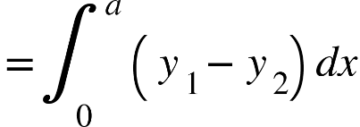

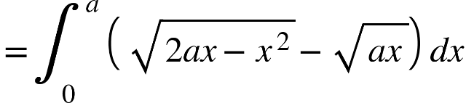

Now, 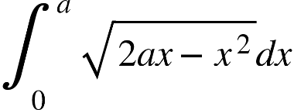 let,{"mathml":"<math style=\"font-family:stix;font-size:16px;\" xmlns=\"http://www.w3.org/1998/Math/MathML\"><mi>x</mi><mo>=</mo><mn>2</mn><mi>a</mi><mo>&#xA0;</mo><msup><mi>sin</mi><mn>2</mn></msup><mi>&#x3B8;</mi></math>","origin":"MathType Legacy","version":"v3.18.2"}

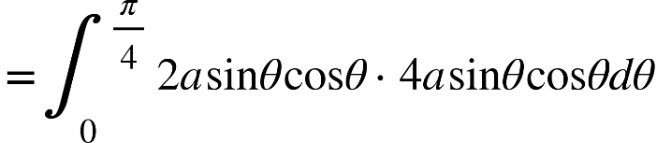

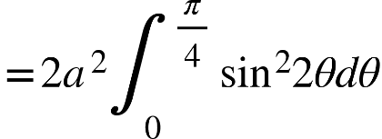

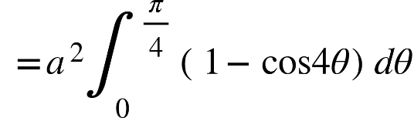

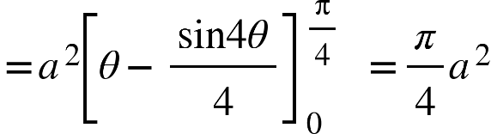

Also. 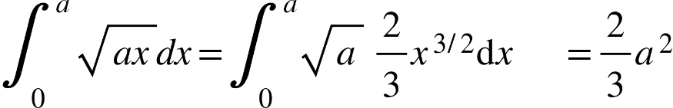

Hence the required area is 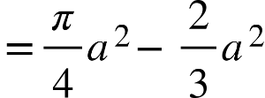 {"mathml":"<math style=\"font-family:stix;font-size:16px;\" xmlns=\"http://www.w3.org/1998/Math/MathML\"><mfenced><mrow><mi>a</mi><mi>n</mi><mi>s</mi></mrow></mfenced></math>","origin":"MathType Legacy","version":"v3.18.2"}

5.Find the whole area of the cycloid {"mathml":"<mml:math style=\"font-family:stix;font-size:16px;\" xmlns:m=\"http://schemas.openxmlformats.org/officeDocument/2006/math\" xmlns:mml=\"http://www.w3.org/1998/Math/MathML\"><mml:mstyle mathsize=\"16px\"><mml:mi>x</mml:mi><mml:mo>=</mml:mo><mml:mi>a</mml:mi><mml:mo>(</mml:mo><mml:mi>&#x3B8;</mml:mi><mml:mo>+</mml:mo><mml:mi mathvariant=\"normal\">s</mml:mi><mml:mi mathvariant=\"normal\">i</mml:mi><mml:mi mathvariant=\"normal\">n</mml:mi><mml:mi>&#x3B8;</mml:mi><mml:mo>)</mml:mo><mml:mo>,</mml:mo><mml:mi>y</mml:mi><mml:mo>=</mml:mo><mml:mi>a</mml:mi><mml:mo>(</mml:mo><mml:mn>1</mml:mn><mml:mo>-</mml:mo><mml:mi>cos</mml:mi><mml:mi>&#x3B8;</mml:mi><mml:mo>)</mml:mo></mml:mstyle></mml:math>","origin":"MathType Legacy","version":"v3.18.2"}.  
Solve:- The area of half the eycloid AOC, is - bounded by the curve, the y-axis and the abscissa and {"mathml":"<mml:math style=\"font-family:stix;font-size:16px;\" xmlns:m=\"http://schemas.openxmlformats.org/officeDocument/2006/math\" xmlns:mml=\"http://www.w3.org/1998/Math/MathML\"><mml:mstyle mathsize=\"16px\"><mml:mi>y</mml:mi><mml:mo>=</mml:mo><mml:mn>2</mml:mn><mml:mi>a</mml:mi></mml:mstyle></mml:math>","origin":"MathType Legacy","version":"v3.18.2"}.

C

A

O

Hence, this area 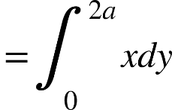

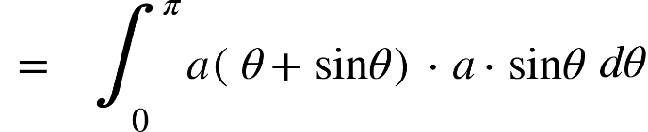

Here,

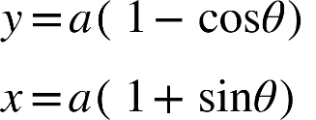

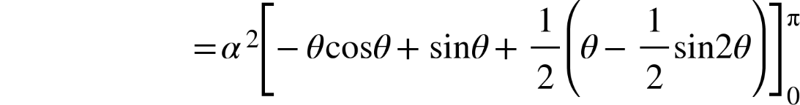

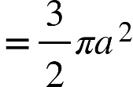.  
Hence, the cycloid area {"mathml":"<math style=\"font-family:stix;font-size:16px;\" xmlns=\"http://www.w3.org/1998/Math/MathML\"><mfenced><mrow><mi>a</mi><mi>n</mi><mi>s</mi></mrow></mfenced></math>","origin":"MathType Legacy","version":"v3.18.2"}

**Area in polar co-ordinates:-**

Let be a curve , where is supposed to be a finite, contineous 4 single valued in . They are bounded by the curve and the radii vactors and is given by the definite integral ==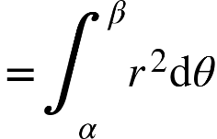

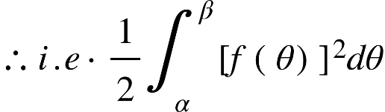 B

O A

Let denote the area POA, bounded by the curve ie & variable radius i.e . if be the neighbouring at {"mathml":"<mml:math style=\"font-family:stix;font-size:16px;\" xmlns:m=\"http://schemas.openxmlformats.org/officeDocument/2006/math\" xmlns:mml=\"http://www.w3.org/1998/Math/MathML\"><mml:mstyle mathsize=\"16px\"><mml:mi>r</mml:mi><mml:mo>+</mml:mo><mml:mo>&#x2206;</mml:mo><mml:mi>r</mml:mi><mml:mo>&#xA0;</mml:mo><mml:mo>,</mml:mo><mml:mi>&#x3B8;</mml:mi><mml:mo>+</mml:mo><mml:mo>&#x2206;</mml:mo><mml:mi>&#x3B8;</mml:mi></mml:mstyle></mml:math>","origin":"MathType Legacy","version":"v3.18.2"} on the curve

elementary area {"mathml":"<mml:math style=\"font-family:stix;font-size:16px;\" xmlns:m=\"http://schemas.openxmlformats.org/officeDocument/2006/math\" xmlns:mml=\"http://www.w3.org/1998/Math/MathML\"><mml:mstyle mathsize=\"16px\"><mml:mi mathvariant=\"normal\">P</mml:mi><mml:mi mathvariant=\"normal\">O</mml:mi><mml:mi mathvariant=\"normal\">Q</mml:mi><mml:mo>(</mml:mo><mml:mi mathvariant=\"normal\">O</mml:mi><mml:mi mathvariant=\"normal\">P</mml:mi><mml:mi mathvariant=\"normal\">N</mml:mi><mml:mi mathvariant=\"normal\">&#x2220;</mml:mi><mml:mi>P</mml:mi><mml:mi>O</mml:mi><mml:mi>Q</mml:mi><mml:mi mathvariant=\"normal\">&#x2220;</mml:mi><mml:mi mathvariant=\"normal\">O</mml:mi><mml:mi>Q</mml:mi><mml:mi>M</mml:mi><mml:mo>)</mml:mo></mml:mstyle></mml:math>","origin":"MathType Legacy","version":"v3.18.2"}

Thus 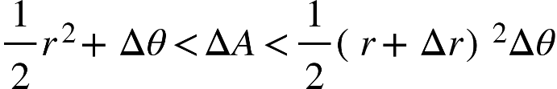

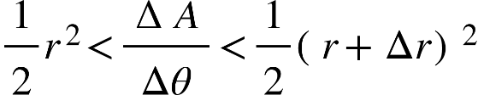

{"mathml":"<mml:math style=\"font-family:stix;font-size:16px;\" xmlns:m=\"http://schemas.openxmlformats.org/officeDocument/2006/math\" xmlns:mml=\"http://www.w3.org/1998/Math/MathML\"><mml:mstyle mathsize=\"16px\"><mml:mo>&#xA0;</mml:mo><mml:mi>as</mml:mi><mml:mo>&#xA0;</mml:mo><mml:mi mathvariant=\"normal\">&#x394;</mml:mi><mml:mi>&#x3B8;</mml:mi><mml:mo>&#x2192;</mml:mo><mml:mn>0</mml:mn></mml:mstyle></mml:math>","origin":"MathType Legacy","version":"v3.18.2"}

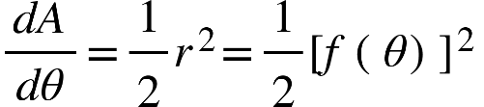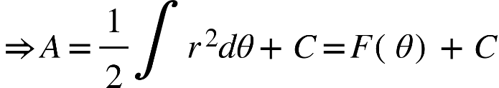

Now {"mathml":"<mml:math style=\"font-family:stix;font-size:16px;\" xmlns:m=\"http://schemas.openxmlformats.org/officeDocument/2006/math\" xmlns:mml=\"http://www.w3.org/1998/Math/MathML\"><mml:mstyle mathsize=\"16px\"><mml:mn>0</mml:mn><mml:mo>=</mml:mo><mml:mi>F</mml:mi><mml:mo>(</mml:mo><mml:mi>&#x3B1;</mml:mi><mml:mo>)</mml:mo><mml:mo>+</mml:mo><mml:mi>C</mml:mi><mml:mo>&#xA0;</mml:mo><mml:mo>&amp;</mml:mo><mml:mo>&#xA0;</mml:mo><mml:msub><mml:mi>A</mml:mi><mml:mn>1</mml:mn></mml:msub><mml:mo>=</mml:mo><mml:mi>F</mml:mi><mml:mo>(</mml:mo><mml:mi>&#x3B2;</mml:mi><mml:mo>)</mml:mo><mml:mo>+</mml:mo><mml:mi>C</mml:mi></mml:mstyle></mml:math>","origin":"MathType Legacy","version":"v3.18.2"}  
where 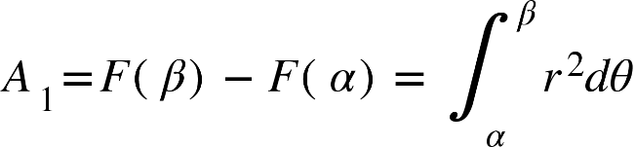

* area bounded by {"mathml":"<mml:math style=\"font-family:stix;font-size:16px;\" xmlns:m=\"http://schemas.openxmlformats.org/officeDocument/2006/math\" xmlns:mml=\"http://www.w3.org/1998/Math/MathML\"><mml:mstyle mathsize=\"16px\"><mml:msub><mml:mi>r</mml:mi><mml:mn>1</mml:mn></mml:msub><mml:mo>=</mml:mo><mml:msub><mml:mi>f</mml:mi><mml:mn>1</mml:mn></mml:msub><mml:mo>(</mml:mo><mml:mi>&#x3B8;</mml:mi><mml:mo>)</mml:mo><mml:mo>&#xA0;</mml:mo><mml:mi mathvariant=\"normal\">&#xA0;</mml:mi><mml:mi>k</mml:mi><mml:msub><mml:mi>r</mml:mi><mml:mn>2</mml:mn></mml:msub><mml:mo>=</mml:mo><mml:msub><mml:mi>f</mml:mi><mml:mn>2</mml:mn></mml:msub><mml:mo>(</mml:mo><mml:mi>&#x3B8;</mml:mi><mml:mo>)</mml:mo></mml:mstyle></mml:math>","origin":"MathType Legacy","version":"v3.18.2"}.

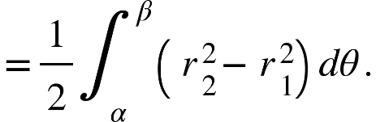

1.Find the area bounded by the cardioide {"mathml":"<mml:math style=\"font-family:stix;font-size:16px;\" xmlns:m=\"http://schemas.openxmlformats.org/officeDocument/2006/math\" xmlns:mml=\"http://www.w3.org/1998/Math/MathML\"><mml:mstyle mathsize=\"16px\"><mml:mi>r</mml:mi><mml:mo>=</mml:mo><mml:mi>a</mml:mi><mml:mo>(</mml:mo><mml:mn>1</mml:mn><mml:mo>-</mml:mo><mml:mi mathvariant=\"normal\">c</mml:mi><mml:mi mathvariant=\"normal\">o</mml:mi><mml:mi mathvariant=\"normal\">s</mml:mi><mml:mi>&#x3B8;</mml:mi><mml:mo>)</mml:mo></mml:mstyle></mml:math>","origin":"MathType Legacy","version":"v3.18.2"}

Solve: The curve in symmetrical abount the initial line since replacing {"mathml":"<mml:math style=\"font-family:stix;font-size:16px;\" xmlns:m=\"http://schemas.openxmlformats.org/officeDocument/2006/math\" xmlns:mml=\"http://www.w3.org/1998/Math/MathML\"><mml:mstyle mathsize=\"16px\"><mml:mi>&#x3B8;</mml:mi></mml:mstyle></mml:math>","origin":"MathType Legacy","version":"v3.18.2"} by ,  
r does not alter. Beginning from and gradually increasing o to .

RRRR Q

o o

A

Now ,the required area is 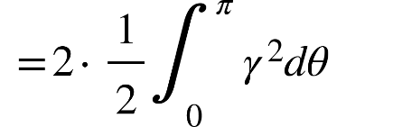

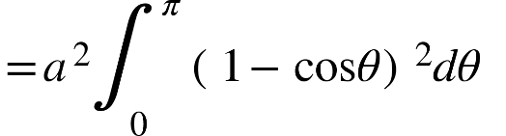 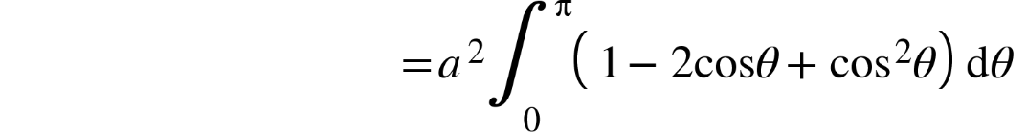

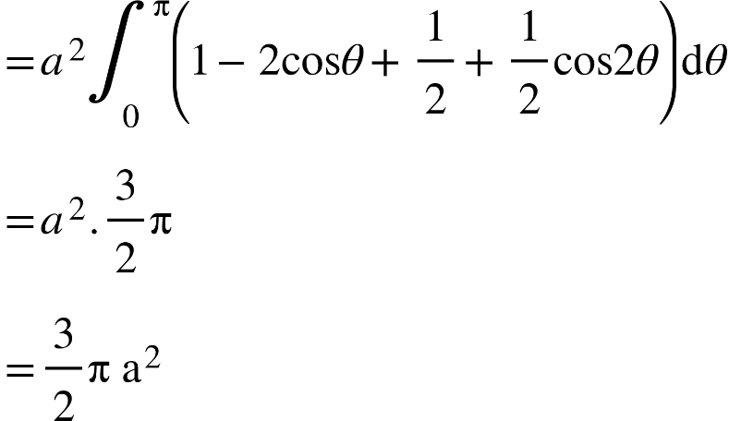

Find the area common to the cardio. {"mathml":"<mml:math style=\"font-family:stix;font-size:16px;\" xmlns:m=\"http://schemas.openxmlformats.org/officeDocument/2006/math\" xmlns:mml=\"http://www.w3.org/1998/Math/MathML\"><mml:mstyle mathsize=\"16px\"><mml:mi>r</mml:mi><mml:mo>=</mml:mo><mml:mi>a</mml:mi><mml:mo>(</mml:mo><mml:mn>1</mml:mn><mml:mo>+</mml:mo><mml:mi mathvariant=\"normal\">c</mml:mi><mml:mi mathvariant=\"normal\">o</mml:mi><mml:mi mathvariant=\"normal\">s</mml:mi><mml:mi>&#x3B8;</mml:mi><mml:mo>)</mml:mo></mml:mstyle></mml:math>","origin":"MathType Legacy","version":"v3.18.2"} and the circle and also the area of the remainder of the Cardioide.  
Solve: At the common point of the two curves, we have

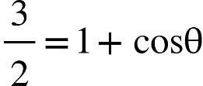

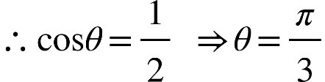

Q P

O C A

R

The required area is {"mathml":"<math style=\"font-family:stix;font-size:16px;\" xmlns=\"http://www.w3.org/1998/Math/MathML\"><mo>=</mo><mn>2</mn><mfenced><mrow><mi>a</mi><mi>r</mi><mi>e</mi><mi>a</mi><mo>&#xA0;</mo><mi>O</mi><mi>C</mi><mi>P</mi><mo>&#xA0;</mo><mo>+</mo><mo>&#xA0;</mo><mi>a</mi><mi>r</mi><mi>e</mi><mi>a</mi><mo>&#xA0;</mo><mi>P</mi><mi>Q</mi><mi>R</mi></mrow></mfenced></math>","origin":"MathType Legacy","version":"v3.18.2"}

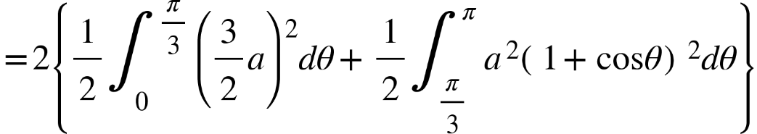

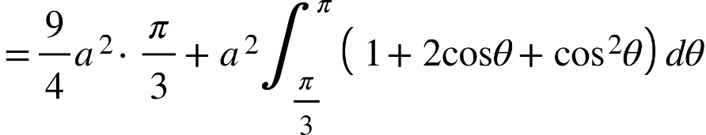

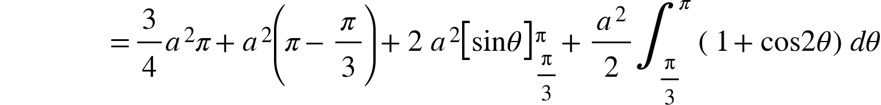

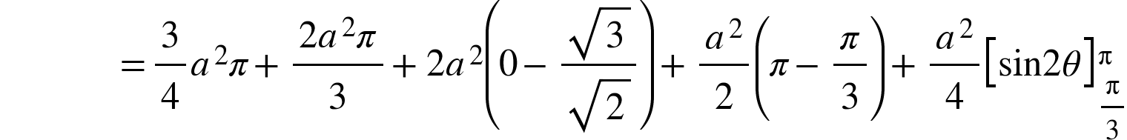

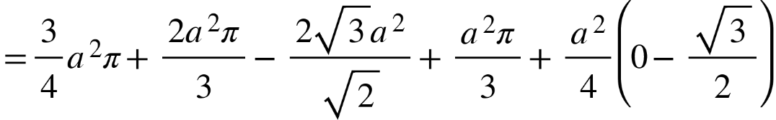

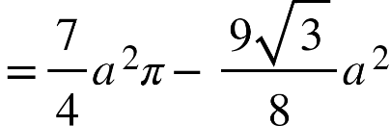 (ans)

Again, the area of they remainder of the Cardioide i. e. APCR

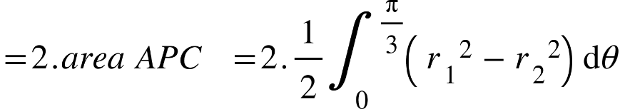

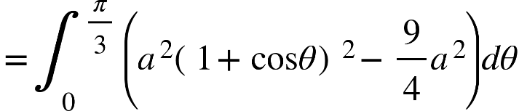

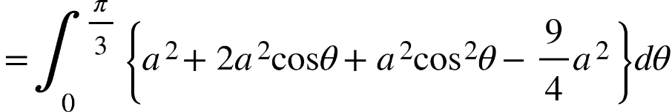

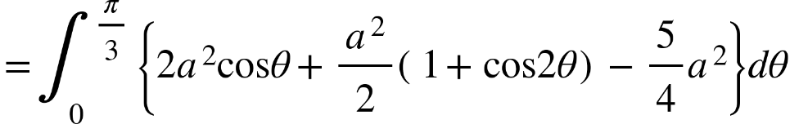

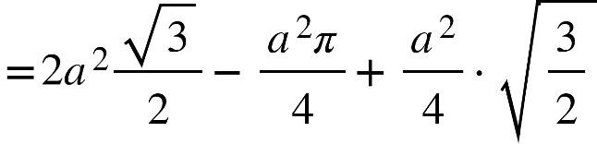

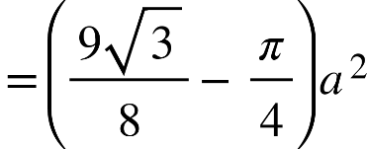 (ans)

**Solids of Revolution:-**

A solid of revolution is a solid that is generated by revolving a plane region about a line that lies in the same plane as the region; the line, is called the axis of revolution.

**P -388 - Volume formula:-** Let S be a solid bounded two parallel planes r to the -axis at and , If, for each in , the cross-sectional area of r to the -axis is ,

x then the volume 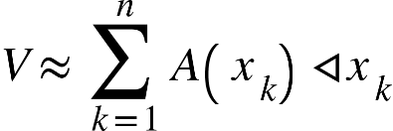

a

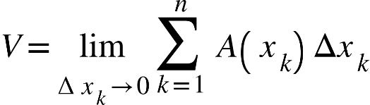

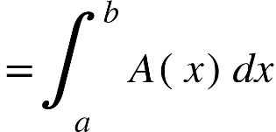

**P-391- Volumes, by disks r to x-axis:-**  
A problem: Let f be contineous and non-negative on , and let be the region that is bounded above by , below by the -axis, and 0 the sides by the lines ,

Find volume of the solid of revolution that is generated by revolving the region about the -axis .

a b a

b

we can solve this problem by slicing. For this purpose, observe that the cross-section of the solid taken to the -axis at the point is a circular disk of radius [(b)]. The area of this region is {"mathml":"<mml:math style=\"font-family:stix;font-size:16px;\" xmlns:m=\"http://schemas.openxmlformats.org/officeDocument/2006/math\" xmlns:mml=\"http://www.w3.org/1998/Math/MathML\"><mml:mstyle mathsize=\"16px\"><mml:mi>A</mml:mi><mml:mo>(</mml:mo><mml:mi>x</mml:mi><mml:mo>)</mml:mo><mml:mo>=</mml:mo><mml:mi>&#x3C0;</mml:mi><mml:mo>[</mml:mo><mml:mi>f</mml:mi><mml:mo>(</mml:mo><mml:mi>x</mml:mi><mml:mo>)</mml:mo><mml:msup><mml:mo>]</mml:mo><mml:mn>2</mml:mn></mml:msup></mml:mstyle></mml:math>","origin":"MathType Legacy","version":"v3.18.2"}

Thus, from (3) the valume of the solid is

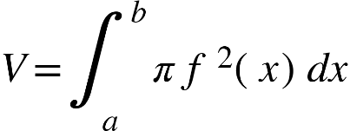

Example-2: Find the volume of the solid that is obtained when the regiont under the curve 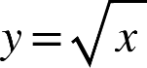 over the interval is revolved about the -axis  
Solve: The volume is, 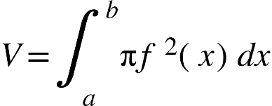

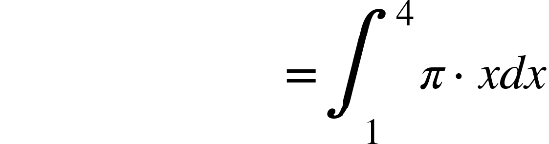

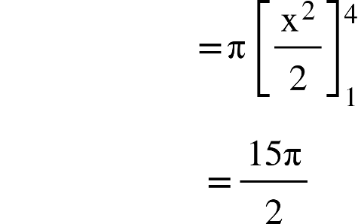

Example-3:Derive the formula for the volume of a sphere of radius r.

Solve:A sphere of radius r can be generated by revolving the upper semicircular disk enclosed between the x-axis and {"mathml":"<math style=\"font-family:stix;font-size:16px;\" xmlns=\"http://www.w3.org/1998/Math/MathML\"><msup><mi>x</mi><mn>2</mn></msup><mo>+</mo><msup><mi>y</mi><mn>2</mn></msup><mo>=</mo><msup><mi>r</mi><mn>2</mn></msup></math>","origin":"MathType Legacy","version":"v3.18.2"} about the x since the upper half of this circle is 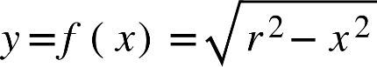

The volume of sphere is 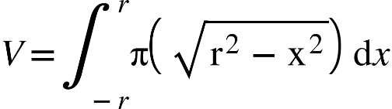

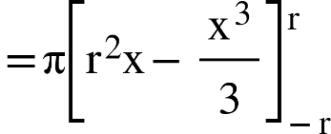

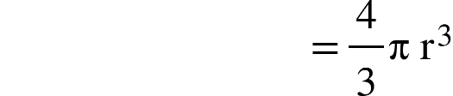

**Volumes by cylindrical shells:**Problem: Let f be contineous and non-negative on 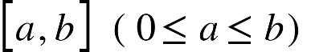and let R be the region that is bounded above by {"mathml":"<math xmlns=\"http://www.w3.org/1998/Math/MathML\" style=\"font-family:stix;font-size:16px;\"><mi>y</mi><mo>&#xA0;</mo><mo>=</mo><mi>f</mi><mfenced><mi>x</mi></mfenced></math>","origin":"MathType Legacy","version":"v3.18.2"},below by the x-axis and on the sides the lines {"mathml":"<math xmlns=\"http://www.w3.org/1998/Math/MathML\" style=\"font-family:stix;font-size:16px;\"><mi>x</mi><mo>&#xA0;</mo><mo>=</mo><mi>a</mi><mo>&#xA0;</mo><mi>a</mi><mi>n</mi><mi>d</mi><mo>&#xA0;</mo><mi>x</mi><mo>=</mo><mo>&#xA0;</mo><mi>b</mi></math>","origin":"MathType Legacy","version":"v3.18.2"}.Find the volume V of the solid of revolution S that is generated by revolving the region R about the y-axis .

a

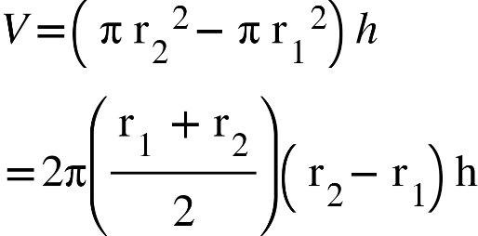

{"mathml":"<math xmlns=\"http://www.w3.org/1998/Math/MathML\" style=\"font-family:stix;font-size:16px;\"><mo>&#x2206;</mo><msub><mi>x</mi><mi>k</mi></msub><mo>=</mo><msub><mi>x</mi><mi>k</mi></msub><mo>-</mo><msub><mi>x</mi><mrow><mi>k</mi><mo>-</mo><mn>1</mn></mrow></msub></math>","origin":"MathType Legacy","version":"v3.18.2"}

If {"mathml":"<math style=\"font-family:stix;font-size:16px;\" xmlns=\"http://www.w3.org/1998/Math/MathML\"><msup><msub><mi>x</mi><mi>k</mi></msub><mo>*</mo></msup></math>","origin":"MathType Legacy","version":"v3.18.2"} be the midpoint of the interval 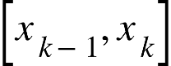 and if we construct rectangle of height 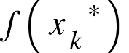over the interval then,

{"mathml":"<math xmlns=\"http://www.w3.org/1998/Math/MathML\" style=\"font-family:stix;font-size:16px;\"><msub><mi>V</mi><mi>k</mi></msub><mo>=</mo><mn>2</mn><mi mathvariant=\"normal\">&#x3C0;</mi><msup><mrow><mo>&#xA0;</mo><msub><mi mathvariant=\"normal\">x</mi><mi mathvariant=\"normal\">k</mi></msub></mrow><mo>*</mo></msup><mi mathvariant=\"normal\">f</mi><mfenced><msup><msub><mi mathvariant=\"normal\">x</mi><mi mathvariant=\"normal\">k</mi></msub><mo>*</mo></msup></mfenced><mo>&#x2206;</mo><msub><mi mathvariant=\"normal\">x</mi><mi mathvariant=\"normal\">k</mi></msub><mspace linebreak=\"newline\"/><mi mathvariant=\"normal\">V</mi><mo>&#x2248;</mo><munderover><mo>&#x2211;</mo><mrow><mi mathvariant=\"normal\">k</mi><mo>=</mo><mn>1</mn></mrow><mi mathvariant=\"normal\">n</mi></munderover><mn>2</mn><mi mathvariant=\"normal\">&#x3C0;</mi><msup><mrow><mo>&#xA0;</mo><msub><mi mathvariant=\"normal\">x</mi><mi mathvariant=\"normal\">k</mi></msub></mrow><mo>*</mo></msup><mi mathvariant=\"normal\">f</mi><mfenced><msup><msub><mi mathvariant=\"normal\">x</mi><mi mathvariant=\"normal\">k</mi></msub><mo>*</mo></msup></mfenced><mo>&#x2206;</mo><msub><mi mathvariant=\"normal\">x</mi><mi mathvariant=\"normal\">k</mi></msub><mspace linebreak=\"newline\"/><mi mathvariant=\"normal\">V</mi><mo>=</mo><munder><mi>lim</mi><mrow><mi>max</mi><mo>&#xA0;</mo><mo>&#x2206;</mo><msub><mi mathvariant=\"normal\">x</mi><mi mathvariant=\"normal\">k</mi></msub><mo>&#x2192;</mo><mn>0</mn></mrow></munder><munderover><mo>&#x2211;</mo><mrow><mi mathvariant=\"normal\">k</mi><mo>=</mo><mn>1</mn></mrow><mi mathvariant=\"normal\">n</mi></munderover><mn>2</mn><mi mathvariant=\"normal\">&#x3C0;</mi><msup><mrow><mo>&#xA0;</mo><msub><mi mathvariant=\"normal\">x</mi><mi mathvariant=\"normal\">k</mi></msub></mrow><mo>*</mo></msup><mi mathvariant=\"normal\">f</mi><mfenced><msup><msub><mi mathvariant=\"normal\">x</mi><mi mathvariant=\"normal\">k</mi></msub><mo>*</mo></msup></mfenced><mo>&#x2206;</mo><msub><mi mathvariant=\"normal\">x</mi><mi mathvariant=\"normal\">k</mi></msub><mspace linebreak=\"newline\"/><mo>=</mo><msubsup><mo>&#x222B;</mo><mi mathvariant=\"normal\">a</mi><mi mathvariant=\"normal\">b</mi></msubsup><mn>2</mn><mi mathvariant=\"normal\">&#x3C0;</mi><msup><mrow><mo>&#xA0;</mo><msub><mi mathvariant=\"normal\">x</mi><mi mathvariant=\"normal\">k</mi></msub></mrow><mo>*</mo></msup><mi mathvariant=\"normal\">f</mi><mfenced><msup><msub><mi mathvariant=\"normal\">x</mi><mi mathvariant=\"normal\">k</mi></msub><mo>*</mo></msup></mfenced><mo>d</mo><mi mathvariant=\"normal\">x</mi></math>","origin":"MathType Legacy","version":"v3.18.2"}

Example-1: Use cylindrical shells to find the volume of the solid generated when the region enclosed between 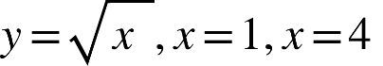 and the x-axis is revolved about the y axis.

Solve: 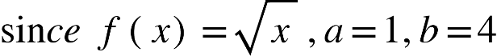

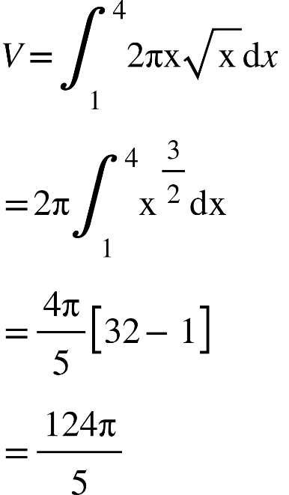

Area of surface revolution :

Arc length: 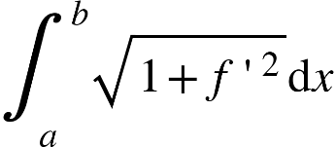

Surface area: A surface of revolution is a surface that is generated by revolving a curve about an axis that lies in the same plane as the curve .

Example-1: Find the area of the surface that is generated by revolving the portion of the curve {"mathml":"<math xmlns=\"http://www.w3.org/1998/Math/MathML\" style=\"font-family:stix;font-size:16px;\"><mi>y</mi><mo>=</mo><msup><mi>x</mi><mn>3</mn></msup></math>","origin":"MathType Legacy","version":"v3.18.2"} between {"mathml":"<math xmlns=\"http://www.w3.org/1998/Math/MathML\" style=\"font-family:stix;font-size:16px;\"><mi>x</mi><mo>=</mo><mn>0</mn><mo>&#xA0;</mo><mi>a</mi><mi>n</mi><mi>d</mi><mo>&#xA0;</mo><mi>x</mi><mo>=</mo><mn>1</mn></math>","origin":"MathType Legacy","version":"v3.18.2"} about the x-axis.

Solve:

X

since {"mathml":"<math xmlns=\"http://www.w3.org/1998/Math/MathML\" style=\"font-family:stix;font-size:16px;\"><mi>y</mi><mo>=</mo><msup><mi>x</mi><mn>3</mn></msup></math>","origin":"MathType Legacy","version":"v3.18.2"} we have 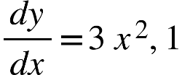 and hence surface area

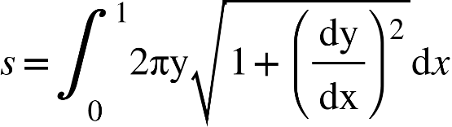

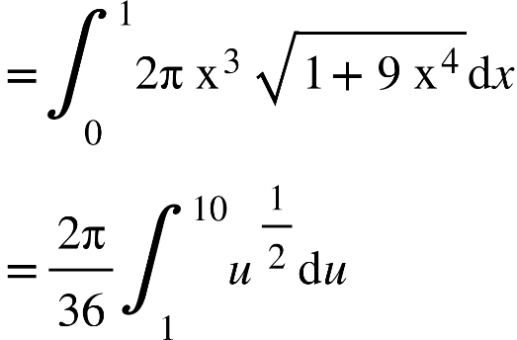

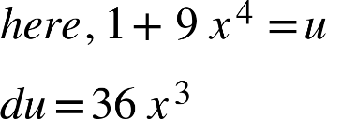

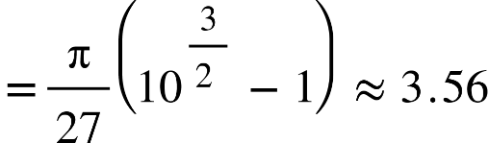

Example-2: Find the area of the surface that is generated by revolving the portion of the curve{"mathml":"<math style=\"font-family:stix;font-size:16px;\" xmlns=\"http://www.w3.org/1998/Math/MathML\"><mi>y</mi><mo>=</mo><msup><mi>x</mi><mn>2</mn></msup></math>","origin":"MathType Legacy","version":"v3.18.2"} between {"mathml":"<math style=\"font-family:stix;font-size:16px;\" xmlns=\"http://www.w3.org/1998/Math/MathML\"><mi>x</mi><mo>=</mo><mn>1</mn><mo>&#xA0;</mo><mo>&#xA0;</mo><mi>a</mi><mi>n</mi><mi>d</mi><mo>&#xA0;</mo><mi>x</mi><mo>=</mo><mn>2</mn></math>","origin":"MathType Legacy","version":"v3.18.2"} about the y-axis.

(2,4)

(1,1)

Solve: 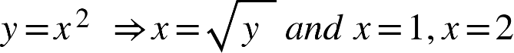 corresponding to {"mathml":"<math xmlns=\"http://www.w3.org/1998/Math/MathML\" style=\"font-family:stix;font-size:16px;\"><mi>y</mi><mo>=</mo><mn>1</mn><mo>&#xA0;</mo><mo>,</mo><mi>y</mi><mo>=</mo><mn>4</mn></math>","origin":"MathType Legacy","version":"v3.18.2"}

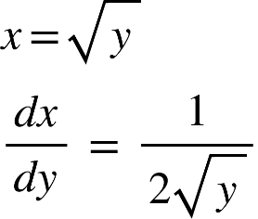

Surface area S,

{"mathml":"<math xmlns=\"http://www.w3.org/1998/Math/MathML\" style=\"font-family:stix;font-size:16px;\"><mo>=</mo><msubsup><mo>&#x222B;</mo><mn>1</mn><mn>4</mn></msubsup><mn>2</mn><mi>&#x3C0;x</mi><msqrt><mn>1</mn><mo>+</mo><msup><mfenced open=\"[\" close=\"]\"><mfrac><mi>dx</mi><mi>dy</mi></mfrac></mfenced><mn>2</mn></msup></msqrt><mo>d</mo><mi>y</mi><mspace linebreak=\"newline\"/><mo>=</mo><msubsup><mo>&#x222B;</mo><mn>1</mn><mn>4</mn></msubsup><mn>2</mn><mi>&#x3C0;</mi><msqrt><mi>y</mi></msqrt><msqrt><mn>1</mn><mo>+</mo><msup><mfenced open=\"[\" close=\"]\"><mfrac><mn>1</mn><mrow><mn>2</mn><msqrt><mi>y</mi></msqrt></mrow></mfrac></mfenced><mn>2</mn></msup></msqrt><mo>d</mo><mi>y</mi><mspace linebreak=\"newline\"/><mo>=</mo><mi mathvariant=\"normal\">&#x3C0;</mi><msubsup><mo>&#x222B;</mo><mn>1</mn><mn>4</mn></msubsup><msqrt><mn>4</mn><mi mathvariant=\"normal\">y</mi><mo>+</mo><mn>1</mn></msqrt><mo>d</mo><mi mathvariant=\"normal\">y</mi><mo>&#xA0;</mo><mo>&#xA0;</mo><mo>&#xA0;</mo><mo>&#xA0;</mo><mo>&#xA0;</mo><mo>&#xA0;</mo><mo>&#xA0;</mo><mo>&#xA0;</mo><mo>&#xA0;</mo><mo>&#xA0;</mo><mo>&#xA0;</mo><mo>&#xA0;</mo><mo>&#xA0;</mo><mo>&#xA0;</mo><mo>&#xA0;</mo><mo>&#xA0;</mo><mo>&#xA0;</mo><mo>&#xA0;</mo><mo>&#xA0;</mo><mo>&#xA0;</mo><mo>&#xA0;</mo><mo>&#xA0;</mo><mo>&#xA0;</mo><mo>&#xA0;</mo><mo>&#xA0;</mo><mo>&#xA0;</mo><mo>&#xA0;</mo><mo>&#xA0;</mo><mo>&#xA0;</mo><mi>here</mi><mo>,</mo><mi mathvariant=\"normal\">u</mi><mo>=</mo><mn>4</mn><mi mathvariant=\"normal\">y</mi><mo>+</mo><mn>1</mn><mspace linebreak=\"newline\"/><mo>=</mo><mfrac><mi mathvariant=\"normal\">&#x3C0;</mi><mn>4</mn></mfrac><msubsup><mo>&#x222B;</mo><mn>5</mn><mn>17</mn></msubsup><msup><mi mathvariant=\"normal\">u</mi><mfrac><mn>1</mn><mn>2</mn></mfrac></msup><mo>d</mo><mi mathvariant=\"normal\">u</mi><mo>&#xA0;</mo><mo>&#xA0;</mo><mo>&#xA0;</mo><mo>&#xA0;</mo><mo>&#xA0;</mo><mo>&#xA0;</mo><mo>&#xA0;</mo><mo>&#xA0;</mo><mo>&#xA0;</mo><mo>&#xA0;</mo><mo>&#xA0;</mo><mo>&#xA0;</mo><mo>&#xA0;</mo><mo>&#xA0;</mo><mo>&#xA0;</mo><mo>&#xA0;</mo><mo>&#xA0;</mo><mo>&#xA0;</mo><mo>&#xA0;</mo><mo>&#xA0;</mo><mo>&#xA0;</mo><mo>&#xA0;</mo><mo>&#xA0;</mo><mo>&#xA0;</mo><mo>&#xA0;</mo><mo>&#xA0;</mo><mo>&#xA0;</mo><mo>&#xA0;</mo><mo>&#xA0;</mo><mo>&#xA0;</mo><mo>&#xA0;</mo><mo>&#xA0;</mo><mo>&#xA0;</mo><mo>&#xA0;</mo><mo>&#xA0;</mo><mo>&#xA0;</mo><mo>&#xA0;</mo><mo>&#xA0;</mo><mo>&#xA0;</mo><mo>&#xA0;</mo><mo>&#xA0;</mo><mo>&#xA0;</mo><mo>&#xA0;</mo><mi>du</mi><mo>=</mo><mn>4</mn><mi>dy</mi><mspace linebreak=\"newline\"/><mo>=</mo><mfrac><mi mathvariant=\"normal\">&#x3C0;</mi><mn>6</mn></mfrac><mfenced><mrow><msup><mn>17</mn><mfrac><mn>3</mn><mn>2</mn></mfrac></msup><mo>-</mo><msup><mn>5</mn><mfrac><mn>3</mn><mn>2</mn></mfrac></msup></mrow></mfenced><mspace linebreak=\"newline\"/><mo>&#x2248;</mo><mn>30</mn><mo>.</mo><mn>85</mn><mspace linebreak=\"newline\"/></math>","origin":"MathType Legacy","version":"v3.18.2"}